МОУ Лицей №130 имени академика М.А.Лаврентьева, Новосибирск
Проект «Почему я должен посетить Великобританию»

Climate
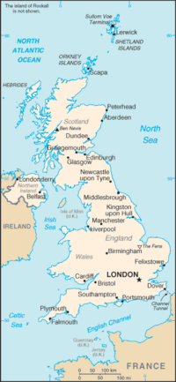
The mountains, the Atlantic Ocean and the warm waters of the Gulf Stream influence the climate of Great Britain. The weather in GB is very changeable. A fine morning can change into a wet afternoon and evening and the wrong side out. The English people say: "Other countries have a climate; in England we have weather." The English also say that they have three variants of weather: when it rains in the morning, when it rains in the afternoon or when it rains all day long. The best time of the year in GB is spring (of course, it rains in spring too). The two worst months in Britain are January and February. They are cold, damp and unpleasant. Summer months are rather cold and there can be a lot of rainy days. So most people who look forward to summer holidays, plan to go abroad for the summer.

