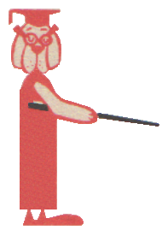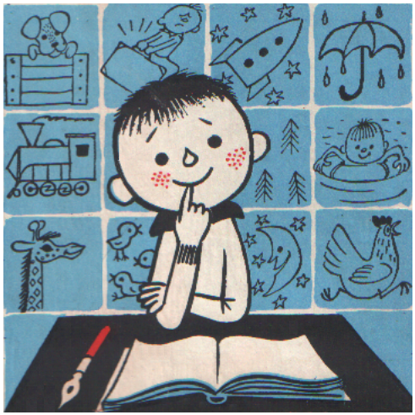

Fill in the blanks using the right form of the verb in bold:
1 | He nodded as if ……… “yes”. | said  say  telling  told  says  say  told  to say  saying  tell  tells  said  say  said to  to tell
2 | A thing well …… will be wit in all languages.
3 | I have never been hurt by anything I didn’t …..
4 | Do as you are …….. .
5 | The long strain was ……… on his health.
6 | “Don’t shout”, I …….. to him.
7 | I …….. him not to shout.
8 | Never …….. never.
9 | Pete …….. that he can swim.
10 | What will Mrs. Grundy …….. ?
11 | It goes without ……… .
12 | ……… her not to take it.
13 | George couldn’t help me. He ……. to ask Jack.
14 | ………. tales out of school.
15 | She ……… us she likes to skate.

