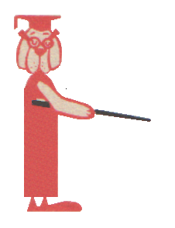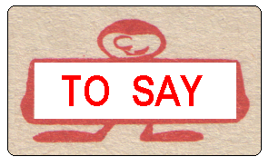
The teacher says, “Good morning!”
And who says this:
Wash your hands before dinner! | the conductor
How are you feeling today? | the doctor
Here is a letter for you! | the militiaman
You may cross the street now. | the postman
Tickets, please. | mother
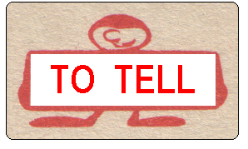
What does the teacher tell you?

to raise our hands to spell a word
to answer the question to clean the blackboard
to come up to the table to bring her our day-books
to go to our desks to write neatly

What does your mother usually tell you to do?

in the morning? | to do your homework
when you come home from school? | to go for a walk
in the evening? | to wash your hands
before you go to bed? | to help her

