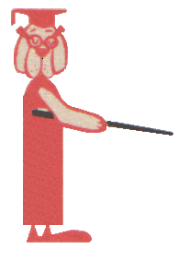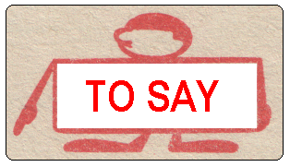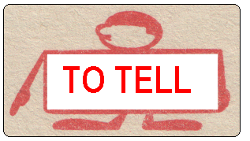
What did he say?
What did he tell you?

“ Read chapter 6 for homework.” | “Pick up your clothes.” | “You should drive more carefully.”
“It will rain tomorrow.” | “I’m watching the news.” | “I was angry yesterday.”
“I’ve already read the book.” | “Put that back.” | “I have a headache.”
“He hasn’t got an extra pencil.” | “I have to work to night.” | “I have already seen that movie.”
“She is still studying.” | “I am going to take a bath now.” | “I can give you these French pens.”
“This is my sister.” | “I ate dinner at 10.” | II must go now.”
“I’ll be here on time.” | “I went there with a friend of mine.” | I’m going to the theatre with my cousin.”
“I have read “Hamlet” in English” | “This book is still up-to-date.” | “I like apples better than oranges.”
“I played chess yesterday.” | “I was ready ten minutes ago.” | “I haven’t bought a new hat.”
“I play the piano wonderfully.” | “I don’t like the way James is speaking.” | “I look pale today.”
“I have never smoked.” | “I heard the news yesterday.” | “This film will be on tomorrow.”

